**Lab 11 Activity 1**

TITLE LAB 11 ACTIVITY 1

.MODEL SMALL

.STACK 100H

.DATA

array db 13 dup (?)

.CODE

MAIN PROC

MOV AX,@DATA

MOV DS,AX

mov cx,14

mov SI,offset array

mov [SI],00h

mov [SI+1],01h

again:

mov al,[SI]

mov bl,[SI+1]

add al,bl

mov [SI+2],al

inc SI

loop again

MOV AH,4CH

INT 21H

MAIN ENDP

END MAIN

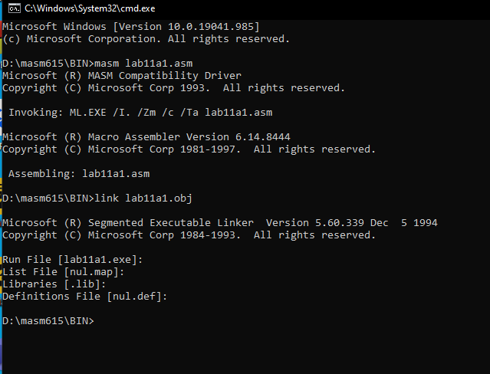

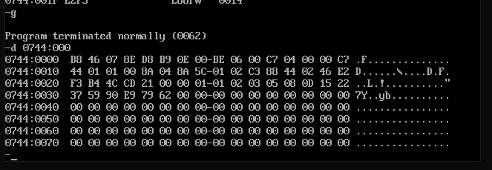

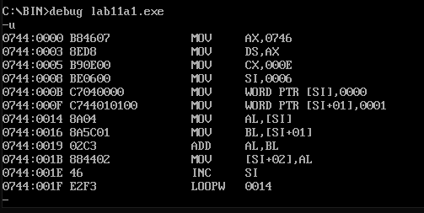

**Lab 11 Activity 2**

**TITLE LAB 11 ACTIVITY 2**

**.MODEL SMALL**

**.STACK 100H**

**.DATA**

**MSG DB 'ENETR A DIGIT TO PRINT THE FACTORIALS = $'**

**.CODE**

**MAIN PROC**

**MOV AX,@DATA**

**MOV DS,AX**

**MOV AH,9**

**LEA DX,MSG**

**INT 21H**

**MOV AH,1**

**INT 21H**

**SUB AL,30H**

**MOV CL,AL**

**SUB CL,1**

**MOV BL,AL**

**SUB BL,1**

**AGAIN:**

**MUL BL**

**SUB BL,1**

**LOOP AGAIN**

**MOV AH,4CH**

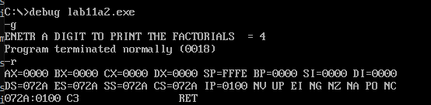**INT 21H**

**MAIN ENDP**

**END MAIN**